Table of Contents
Table of Contents
1. Abstract 3
2. Introduction 3
2.1 Advantages of Proposed System 3
3. Scope and Modules 4
3.1 Scope 4
3.2 System Modules 4
3.3 System Limitations 4
4. Tools and Technologies 4
5. Database Design 5
5.1 SQL Queries (Phase 1) 5
5.2 ERD (Phase 1 - SQL) 7
5.3 JSON Schema (Phase 2 - MongoDB) 8
6. Detailed Implementation Explanation 13
Architecture 13
Key Logic Implemented 13
7. Screenshots of Results 14
8. GUI Screenshots 17
9. Issues Faced and Resolution 19
10. Conclusion 19

Project Category: (Select the major domain of proposed project)
- A-Desktop Application/Information System B-Web Application/Web Application based Information System C- Smartphone Application

1. Abstract
The Vehicle Rental System is designed to automate and simplify the process of renting vehicles such as cars, bikes, and vans. The system allows customers to browse available vehicles, check rental prices, place bookings, and manage their rental history. Administrators can add vehicles, update availability, manage customers, process bookings, and monitor returns.
This project is developed in two phases:
- Phase 1: Using Oracle Relational SQL, focusing on structured data, constraints, and relationships.
- Phase 2: Using MongoDB, shifting the same system to a flexible document-based model without changing the GUI.
The aim was to understand database design in both SQL and NoSQL while building a complete, user-friendly rental management application.

2. Introduction
Many rental agencies still rely on manual entries, phone calls, and paper-based processes. This leads to issues like double bookings, lost records, slow customer service, inaccurate pricing, and difficulty managing vehicle availability. A digital system solves these problems by keeping everything organized on a single platform.
Through this project, I learned how to design an ERD, create relational tables, implement foreign keys, and write SQL queries involving JOINs, GROUP BY, and CRUD operations. I also gained hands-on experience with MongoDB, focusing on collections, JSON schema design, document modeling, and aggregation pipelines. Additionally, I learned how to design a GUI and connect it with both databases.

2.1 Advantages of Proposed System
- Eliminates manual paperwork and reduces human mistakes.
- Fast search and retrieval of vehicles, bookings, and customer records.
- Prevents double-booking through real-time availability updates.
- Scalable system with flexible database design (MongoDB).
- User-friendly interface for both admin and customers.
- Secure data storage with consistent record-keeping.

3. Scope and Modules

3.1 Scope
The scope of this system covers customer registration, vehicle browsing, booking requests, rental approvals, and vehicle returns. Administrators are able to manage vehicles, update availability, view rental statistics, and maintain customer accounts.
- In Phase 1, all operations run using SQL tables with relationships and queries.
- In Phase 2, the same functionality is supported through MongoDB Collections and Aggregation Pipelines.
Exclusions: The system does not include online payment integration (gateway), insurance processing, GPS tracking, or driver assignment. The focus is strictly on the booking and rental workflow.

3.2 System Modules
Module 1: Customer Module
This module manages customer registration, login, and profile updates. Customers can browse the list of available vehicles, filter by category or price, and submit booking requests. They can view their ongoing rentals and booking history. The module ensures customers can only book available vehicles.
Module 2: Admin Module
Administrators manage the entire rental process. They can add new vehicles, update their status, record vehicle returns, and view "Top Customers" reports. This module ensures proper record-keeping and helps maintain efficient operations.

3.3 System Limitations
- Requires installation and configuration of Oracle SQL and MongoDB.
- Requires stable system resources for GUI and database connection.
- Not designed for heavy enterprise-level datasets (Big Data).

4. Tools and Technologies
Category | Tool/Technology | Version | Rationale
IDE | MS Visual Studio Code | 2025 | Development Environment
DBMS | Oracle SQL | 19c / 2023 | Relational Database Management
DBMS | MongoDB | 8.2.2 | NoSQL Document Database
Design | Draw.io | Online | ERD
Documentation | MS Word | 2025 | Report Writing
Language | Java | 21 / 25 | Backend Logic
Query Language | SQL | 2025 | Database Interaction
GUI Library | Java Swing | - | Desktop Interface

5. Database Design

5.1 SQL Queries (Phase 1)
1. Admin Login Verification
SELECT AdminID FROM Admins WHERE TRIM(Username) = ? AND HashedPassword = ?
2. Customer Login Verification
SELECT CustomerID, Name FROM Customers WHERE TRIM(Username) = ? AND HashedPassword = ?
3. Check Existing Username (Signup)
SELECT COUNT(*) FROM Customers WHERE Username = ?
4. Create New Customer Account
INSERT INTO Customers (Name, MobileNumber, Username, HashedPassword) VALUES (?, ?, ?, ?)
5. Check Vehicle Availability Status (Dashboard Renderer)
SELECT COUNT(*) FROM Bookings WHERE VehicleID=? AND CustomerID=? AND Status='Booked'
6. Load All Vehicles (Customer View)
SELECT VehicleID, Model, Category, RentPerDay, Available FROM Vehicles ORDER BY VehicleID
7. Create New Booking
INSERT INTO Bookings (CustomerID, VehicleID, Status) VALUES (?, ?, 'Booked')
8. Update Vehicle Availability to 'No' (After Booking)
UPDATE Vehicles SET Available='N' WHERE VehicleID=?
9. Find Active Booking for Return
SELECT BookingID FROM Bookings WHERE VehicleID=? AND CustomerID=? AND Status='Booked'
10. Update Booking Status to 'Returned'
UPDATE Bookings SET Status='Returned', ReturnDate=SYSDATE WHERE BookingID=?
11. Update Vehicle Availability to 'Yes' (After Return)
UPDATE Vehicles SET Available='Y' WHERE VehicleID=?
12. View Customer Booking History
SELECT b.BookingID, v.Model, b.Status, b.BookingDate, b.ReturnDate
FROM Bookings b
JOIN Vehicles v ON b.VehicleID=v.VehicleID
WHERE b.CustomerID=?
ORDER BY b.BookingID DESC
13. View Customer Payments
SELECT p.PaymentID, v.Model, p.Amount, p.PaymentMethod, p.PaymentDate
FROM Payments p
JOIN Bookings b ON p.BookingID=b.BookingID
JOIN Vehicles v ON b.VehicleID=v.VehicleID
WHERE b.CustomerID=?
ORDER BY p.PaymentDate DESC

14. Admin Report: Top 5 Loyal Customers
SELECT c.Name, c.MobileNumber, COUNT(b.BookingID) as BookingCount
FROM Bookings b
JOIN Customers c ON b.CustomerID = c.CustomerID
GROUP BY c.Name, c.MobileNumber
ORDER BY BookingCount DESC
15. Load All Vehicles (Admin View)
SELECT VehicleID, Model, Category, RentPerDay, Available FROM Vehicles ORDER BY VehicleID
16. Add New Vehicle
INSERT INTO Vehicles (Model, Category, RentPerDay, Available) VALUES (?, ?, ?, 'Y')
17. Update Existing Vehicle Details
UPDATE Vehicles SET Model=?, Category=?, RentPerDay=? WHERE VehicleID=?
18. Delete Vehicle
DELETE FROM Vehicles WHERE VehicleID=?

19. Generate Vehicle Status Report
SELECT COUNT(*) AS Total,
SUM(CASE WHEN Available='Y' THEN 1 ELSE 0 END) AS Avail,
SUM(CASE WHEN Available='N' THEN 1 ELSE 0 END) AS Rented
FROM Vehicles
20. View All Customers
SELECT CustomerID, Name, MobileNumber, Username FROM Customers
21. Delete Customer: Step 1 (Delete Payments)
DELETE FROM Payments WHERE BookingID IN (SELECT BookingID FROM Bookings WHERE CustomerID=?)
22. Delete Customer: Step 2 (Delete Bookings)
DELETE FROM Bookings WHERE CustomerID=?
23. Delete Customer: Step 3 (Delete Account)
DELETE FROM Customers WHERE CustomerID=?
24. Admin View Bookings (Base Query)
SELECT b.BookingID, c.Name, v.Model, b.Status, b.BookingDate
FROM Bookings b
JOIN Customers c ON b.CustomerID = c.CustomerID
JOIN Vehicles v ON b.VehicleID = v.VehicleID
25. Validate Booking ID (Before Payment Recording)
SELECT COUNT(*) FROM Bookings WHERE BookingID=?
26. Record Manual Payment
INSERT INTO Payments (BookingID, Amount, PaymentMethod) VALUES (?, ?, ?)

5.2 ERD (Phase 1 - SQL)
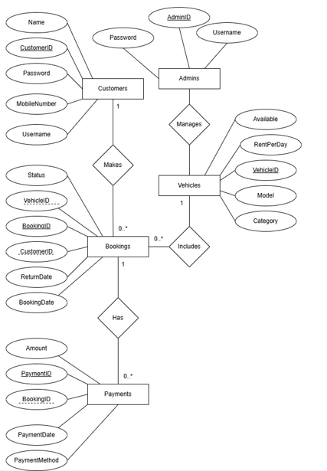
- Customers: CustomerID (PK), Name, MobileNumber, Username, Password.
- Vehicles: VehicleID (PK), Model, Category, RentPerDay, Available.
- Bookings: BookingID (PK), CustomerID (FK), VehicleID (FK), BookingDate, ReturnDate, Status.
- Payments: PaymentID (PK), BookingID (FK), Amount, PaymentMethod, PaymentDate
- Admins: AdminID (PK), Username, Password.

5.3 JSON Schema (Phase 2 - MongoDB)
Collection: Admins
[{
"_id": {
"$oid": "6932894cda0d534678783d79"
},
"AdminID": 1,
"Username": "Ali",
"HashedPassword": "d5083e34522626dd10e151c78c1ba502a3d67427b752c3fd43bd3b944072d1e7"
},
{
"_id": {
"$oid": "6932894cda0d534678783d7a"
},
"AdminID": 2,
"Username": "Hamza",
"HashedPassword": "889b4d97b992b279eab73fd16c7f02d4203f9664d70bf5163bb0c2404473d217"
}]

Collection: Customers
[{
"_id": {
"$oid": "69328983da0d534678783d7b"
},
"CustomerID": 1,
"Name": "Ahmed Khan",
"MobileNumber": "03001234567",
"Username": "ahmedk",
"HashedPassword": "a665a45920422f9d417e4867efdc4fb8a04a1f3fff1fa07e998e86f7f7a27ae3"
},
{
"_id": {
"$oid": "69328983da0d534678783d7c"
},
"CustomerID": 2,
"Name": "Sara Ali",
"MobileNumber": "03007654321",
"Username": "sarali",
"HashedPassword": "e5b2ec1eb34a6f7a78eda6bcdd18b3c3dcfdc90a1d5c66fc2301c1ceaef8fbf4"
},
{
"_id": {
"$oid": "69328983da0d534678783d7d"
},
"CustomerID": 3,
"Name": "Usman Riaz",
"MobileNumber": "03009876543",
"Username": "usmanr",
"HashedPassword": "6ca13d52ca70c883e0f0bb101e425a89e8624de51db2d2392593af6a84118090"
},
{
"_id": {
"$oid": "69328983da0d534678783d7e"
},
"CustomerID": 4,
"Name": "Ayesha Malik",
"MobileNumber": "03005678901",
"Username": "ayesham",
"HashedPassword": "8c6976e5b5410415bde908bd4dee15dfb167a9c873fc4bb8a81f6f2ab448a918"
},
{
"_id": {
"$oid": "69328983da0d534678783d7f"
},
"CustomerID": 5,
"Name": "Bilal Shah",
"MobileNumber": "03003456789",
"Username": "bilals",
"HashedPassword": "ecd71870d1963316a97e3ac3408c9835ad8cf0f3c1bc703527c30265534f75ae"
}]

Collection: Bookings
[{
"_id": {
"$oid": "69328e1c32b83425d5e85a0b"
},
"BookingID": 1,
"CustomerID": 1,
"VehicleID": 6,
"BookingDate": {
"$date": "2025-12-05T07:47:40.492Z"
},
"Status": "Booked"
}]

Collection: Vehicles
[{
"_id": {
"$oid": "6932899eda0d534678783d81"
},
"VehicleID": 2,
"Model": "Honda Civic",
"Category": "Sedan",
"RentPerDay": 55,
"Available": "Y"
},
{
"_id": {
"$oid": "6932899eda0d534678783d84"
},
"VehicleID": 5,
"Model": "Toyota Hilux",
"Category": "Pickup",
"RentPerDay": 100,
"Available": "Y"
},
{
"_id": {
"$oid": "6932899eda0d534678783d87"
},
"VehicleID": 8,
"Model": "Kia Sportage",
"Category": "SUV",
"RentPerDay": 85,
"Available": "Y"
},
{
"_id": {
"$oid": "6932899eda0d534678783d88"
},
"VehicleID": 9,
"Model": "Honda City",
"Category": "Sedan",
"RentPerDay": 45,
"Available": "Y"
},
{
"_id": {
"$oid": "6932899eda0d534678783d89"
},
"VehicleID": 10,
"Model": "Toyota Prius",
"Category": "Hybrid",
"RentPerDay": 60,
"Available": "Y"
},
{
"_id": {
"$oid": "69328acfda0d534678783d8a"
},
"VehicleID": 1,
"Model": "Toyota Corolla",
"Category": "Sedan",
"RentPerDay": 50,
"Available": "Y"
},
{
"_id": {
"$oid": "69328acfda0d534678783d8c"
},
"VehicleID": 3,
"Model": "Suzuki Swift",
"Category": "Hatchback",
"RentPerDay": 40,
"Available": "Y"
},
{
"_id": {
"$oid": "69328acfda0d534678783d8d"
},
"VehicleID": 4,
"Model": "Honda CRV",
"Category": "SUV",
"RentPerDay": 80,
"Available": "Y"
},
{
"_id": {
"$oid": "69328acfda0d534678783d8f"
},
"VehicleID": 6,
"Model": "Suzuki Alto",
"Category": "Hatchback",
"RentPerDay": 35,
"Available": "N"
},
{
"_id": {
"$oid": "69328acfda0d534678783d90"
},
"VehicleID": 7,
"Model": "Nissan X-Trail",
"Category": "SUV",
"RentPerDay": 90,
"Available": "Y"
}]

Collection: Payments
[{
"_id": {
"$oid": "69328e4932b83425d5e85a0c"
},
"PaymentID": 1,
"BookingID": 1,
"Amount": 35,
"PaymentMethod": "cash",
"PaymentDate": {
"$date": "2025-12-05T07:48:25.324Z"
}
},
{
"_id": {
"$oid": "69328e5332b83425d5e85a0d"
},
"PaymentID": 2,
"BookingID": 3,
"Amount": 4,
"PaymentMethod": "3",
"PaymentDate": {
"$date": "2025-12-05T07:48:35.892Z"
}
},
{
"_id": {
"$oid": "69328f4362fb4c53e1b05047"
},
"PaymentID": 3,
"BookingID": 5,
"Amount": 43,
"PaymentMethod": "4",
"PaymentDate": {
"$date": "2025-12-05T07:52:35.512Z"
}
}]
Collection: Counters
[{
"_id": "userid",
"seq": 0
},
{
"_id": "bookingid",
"seq": 1
},
{
"_id": "paymentid",
"seq": 3
}]

6. Detailed Implementation Explanation

Architecture
The application follows an Object-Oriented Programming (OOP) structure. The logic is decoupled into specific classes to ensure maintainability:
- DatabaseManager: A class responsible for handling database connections (Singleton pattern).
- AuthSystem: Handles user login and registration.
- CustomerDashboard: Contains logic for browsing cars and making bookings.
- AdminDashboard: Central control panel for managing vehicles and reports.
- SQL Database: Oracle SQL developer used for SQL database in phase 1.
- Non-SQL Database: Mongo DB used for non SQL database in phase 2.

Key Logic Implemented
- Transactions (SQL): Used conn.setAutoCommit(false) during Booking. This ensures that creating a booking and marking a car as 'Unavailable' happen simultaneously.
- Aggregations (MongoDB): Used Aggregation Pipelines ($lookup, $group, $sort) to generate the "Top Customers" report.
- Validation: Implemented strict checks to ensure Payments cannot be recorded for non-existent Booking IDs.

Screenshots of Results
Oracle SQL:
Admins:
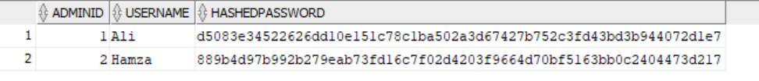
Customers:
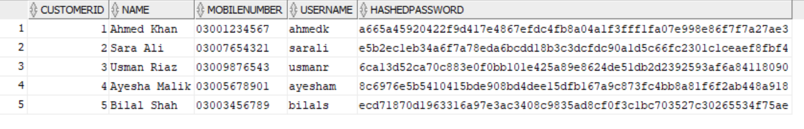
Vehicles:
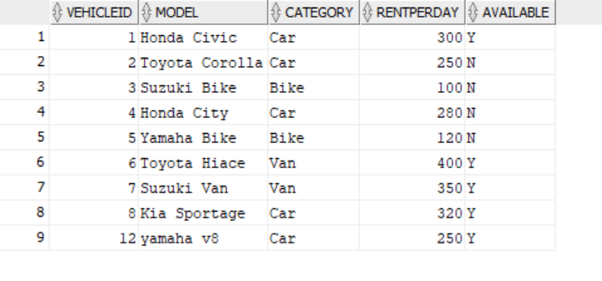
Bookings:
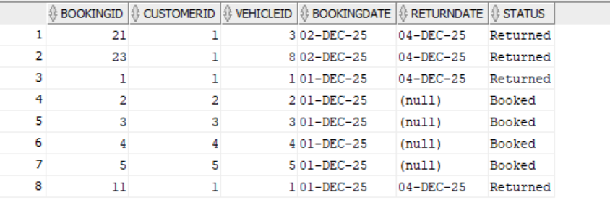
Payments:
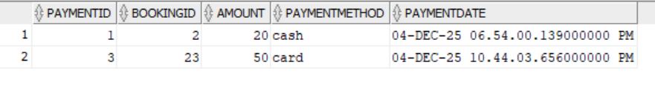

Mongo DB:
Admins:
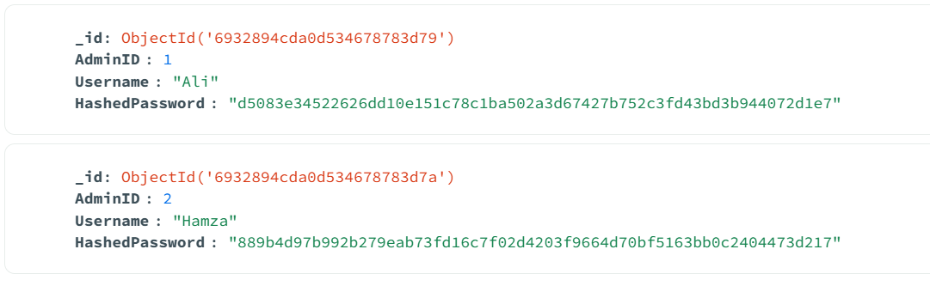
Customers:
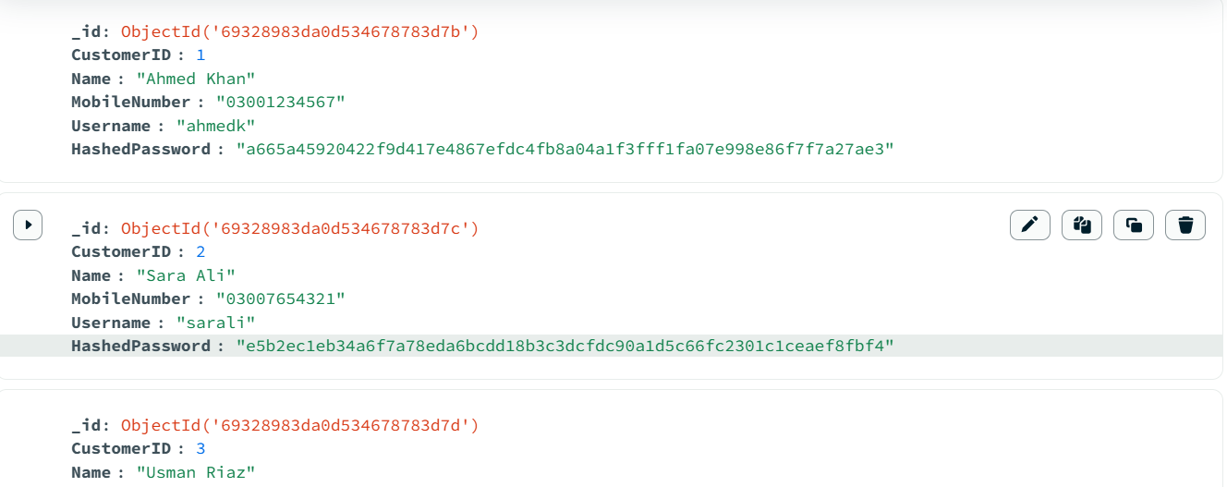

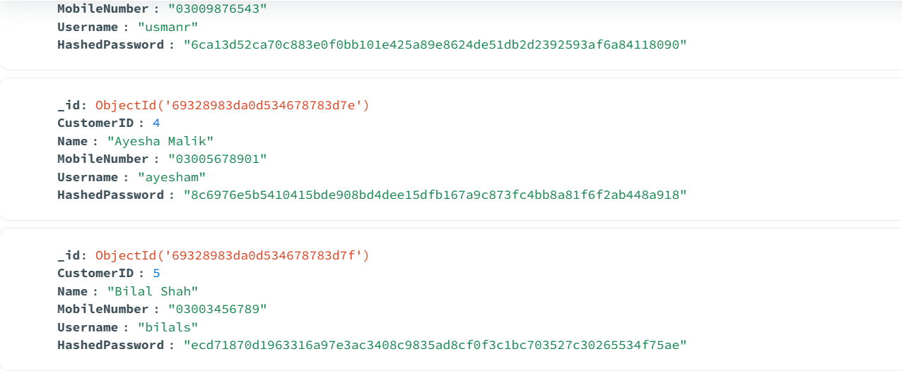

Vehicles (first two and last two):
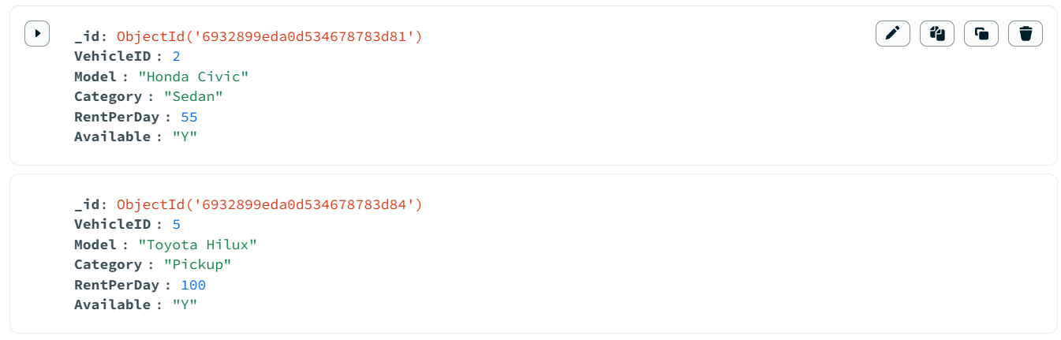
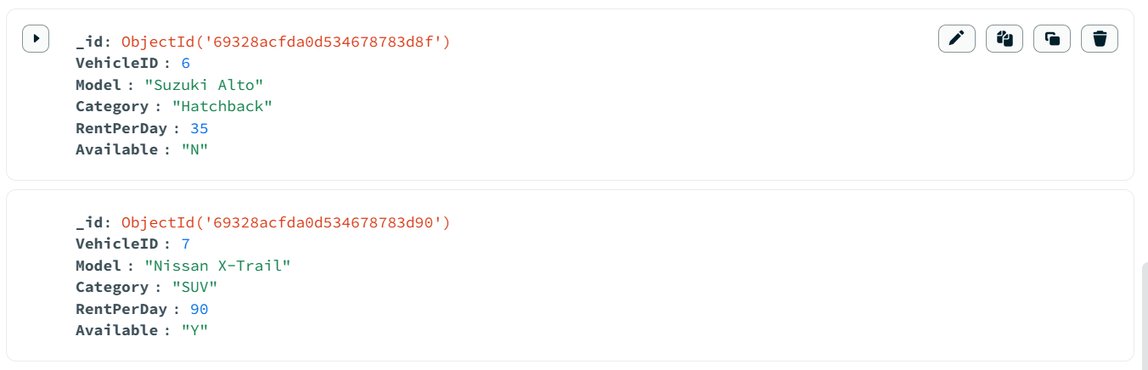
Bookings:
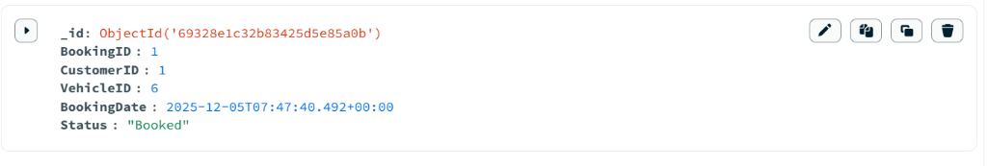
Payments:
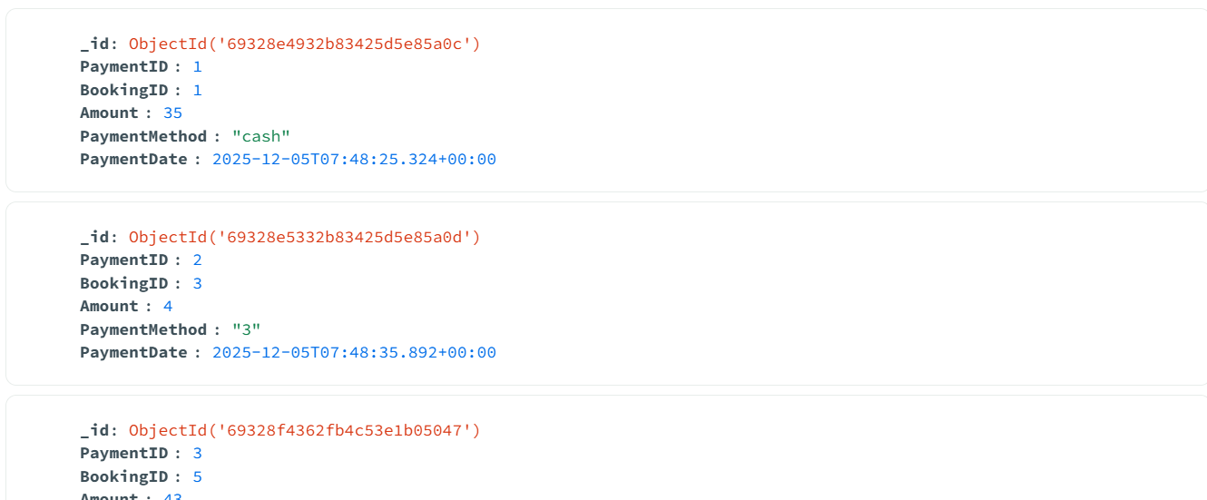
Counters:
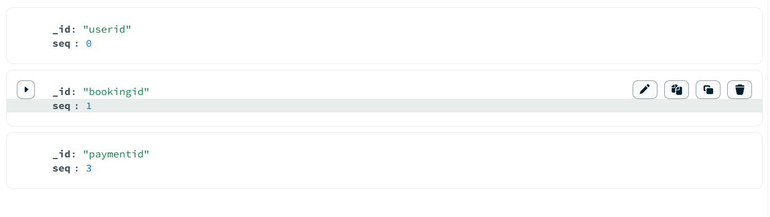

8. GUI Screenshots
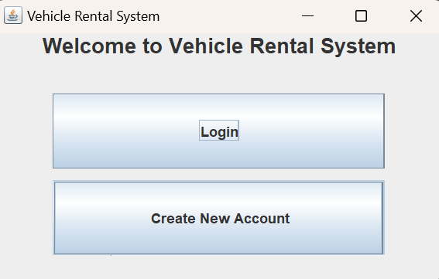
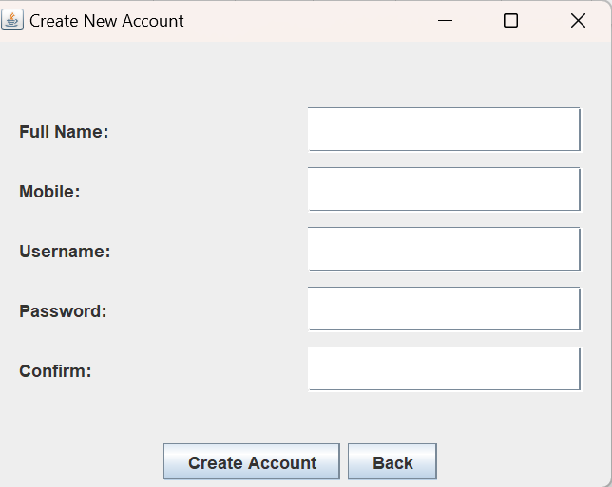
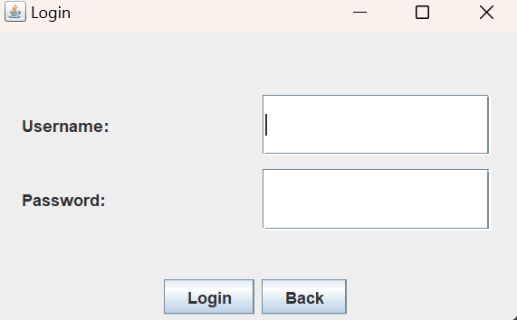

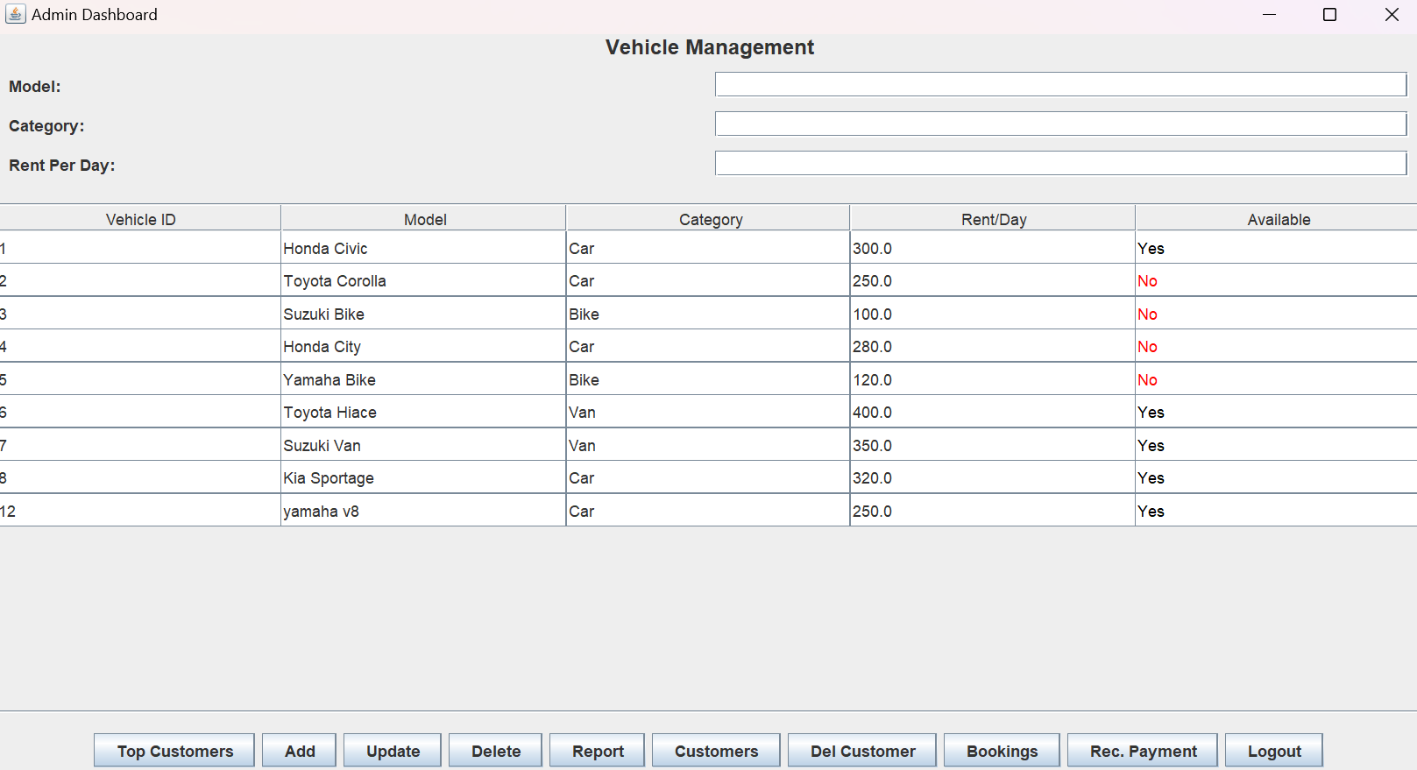
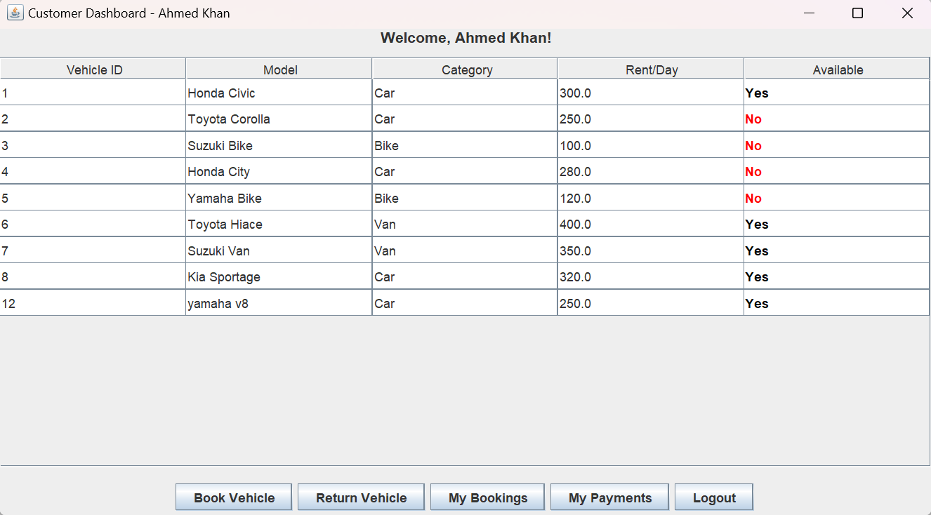

9. Issues Faced and Resolution
- Data Integrity in Payments:
  - Issue: Admins could mistakenly enter a wrong Booking ID when recording payments.
  - Resolution: Added a validation query (SELECT COUNT(*)) before insertion to ensure the ID exists.
- Sorting Logic:
  - Issue: Viewing all bookings was messy.
  - Resolution: Added a custom dialog with filters for "Show All", "Show Active", and "Show Returned".

10. Conclusion
The Vehicle Rental System provides an efficient solution for managing rentals, improving accuracy, and streamlining operations. It offers practical experience in both SQL and NoSQL environments while maintaining a consistent GUI. The project strengthens skills in database design, GUI development, and full-stack application logic.

